This is how the app will look to the users and to the third party. Here it has been used HTML, CSS, and Javascript. Although they are not directly supported by a native Android Application, there exists many “framework” which can translate them into pareseable native code, supporting the functionality of the device’s keys.

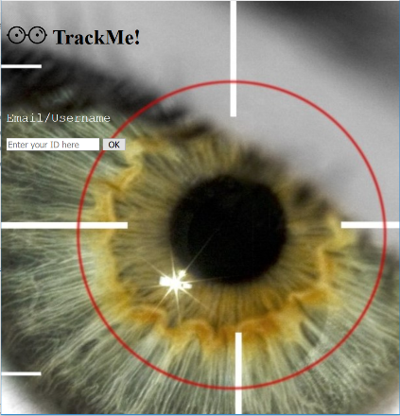

This allows the user/third party to be identified and to be redirected appropriately, whether it is a new user/third party or a registered user/third party.

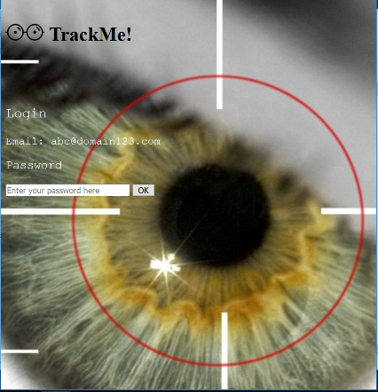

This is the following screen, presented if you are already registered

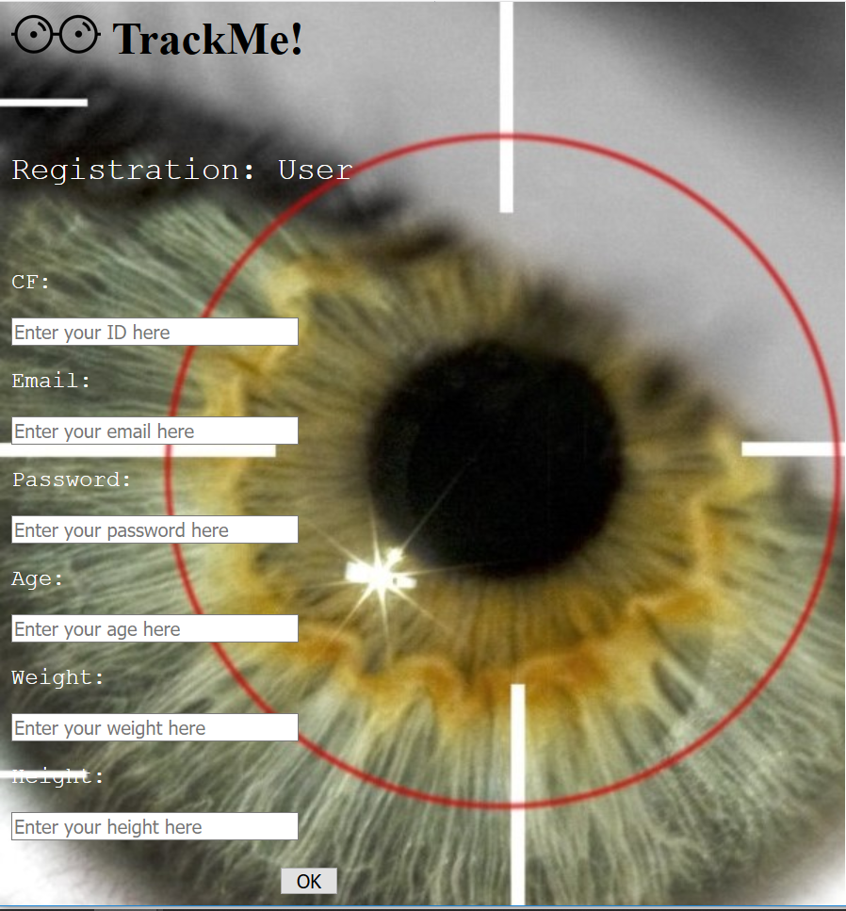

This is the registration page, in case you are an user

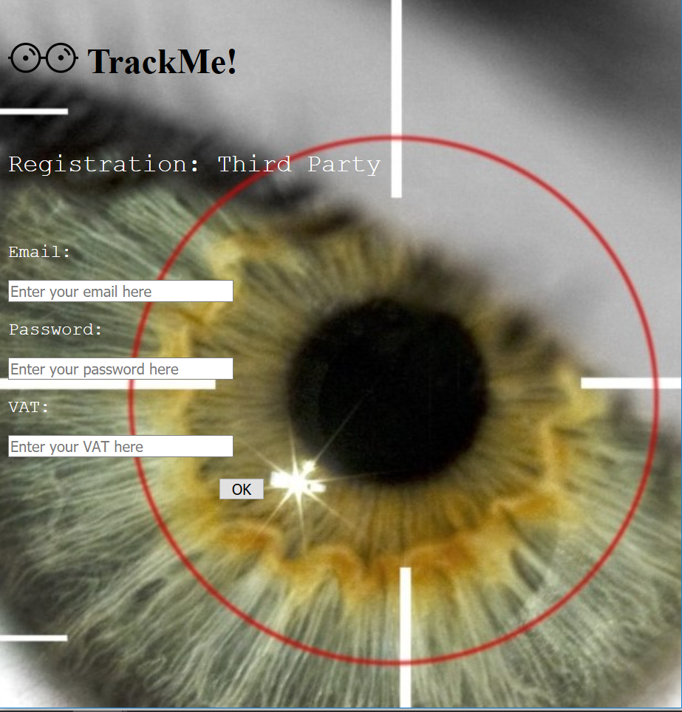

This is instead the registration page when it’s the case of a business



Here the third party will decide what to do, subscribe to new data, or pose a new request, which lead to the next image…

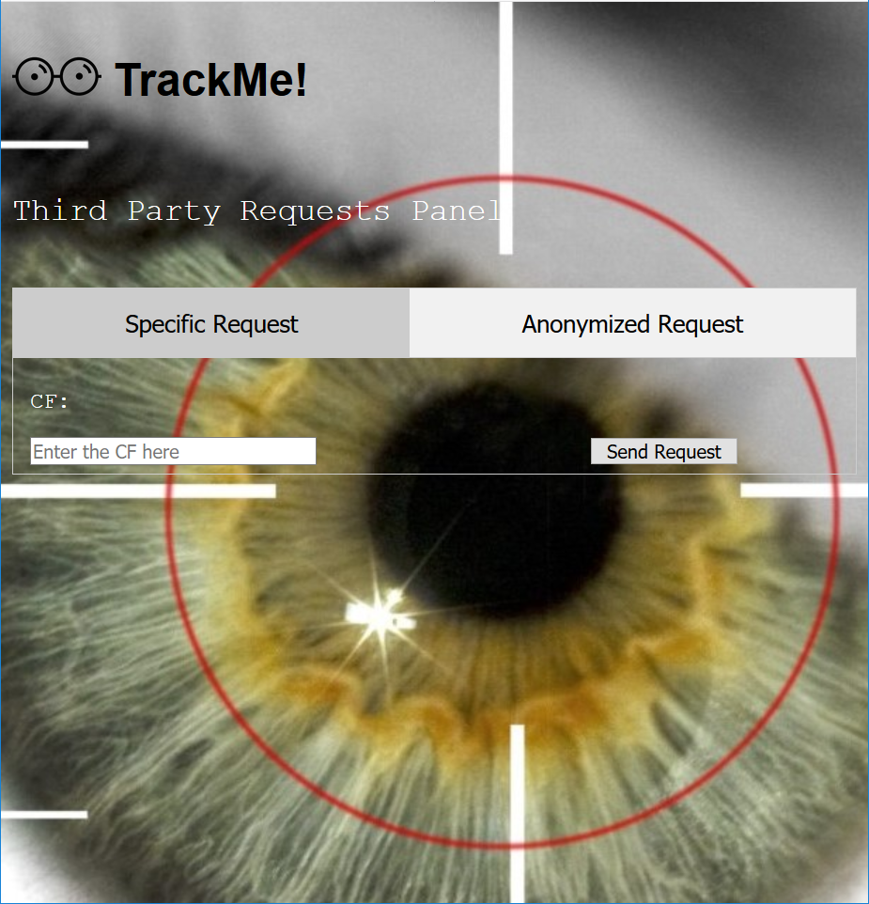

A specific request will need only the CF of the interested user.

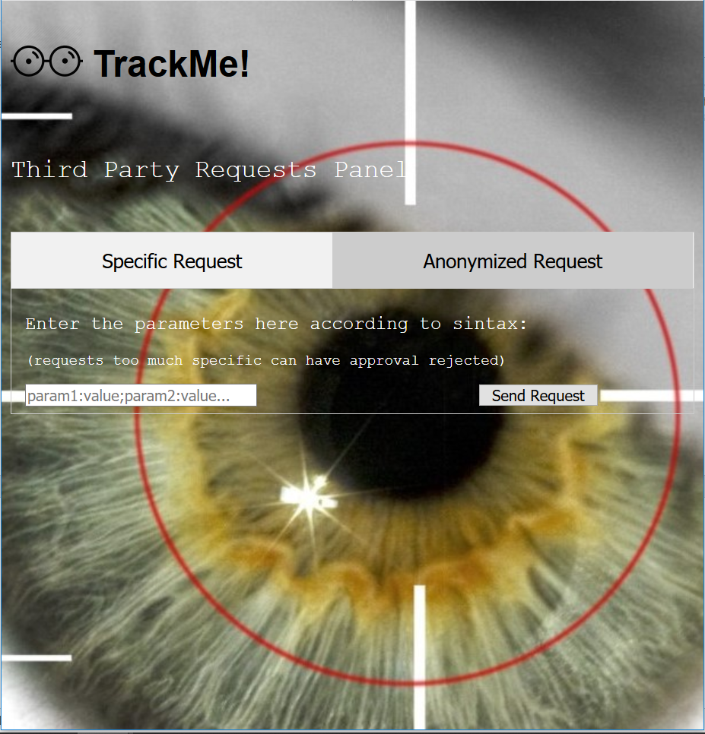

A generalized request will need instead a list of pair: parameter-value, to retrieve the users related to the parameters

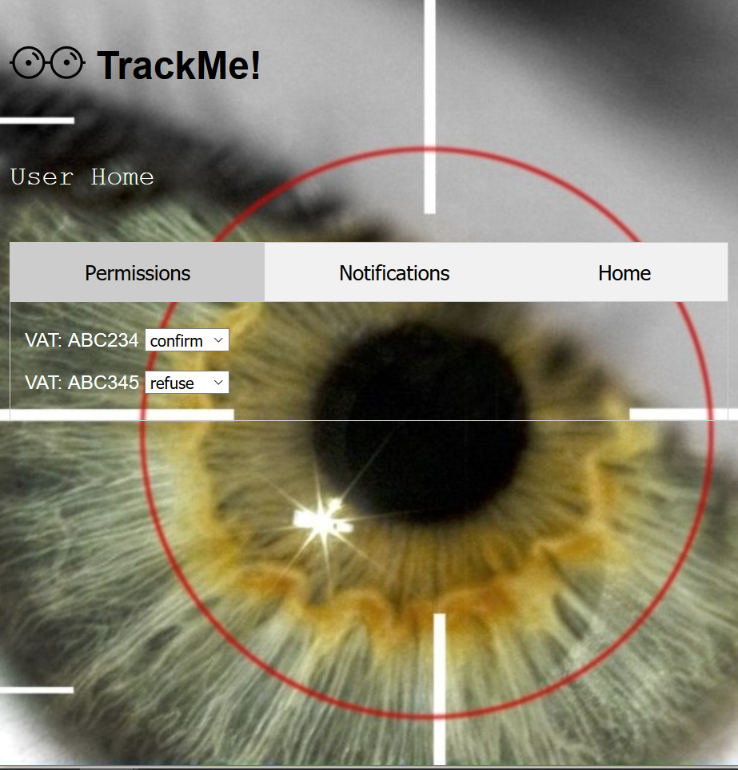

In the permission tab, user side, the user will set each business the right permissions

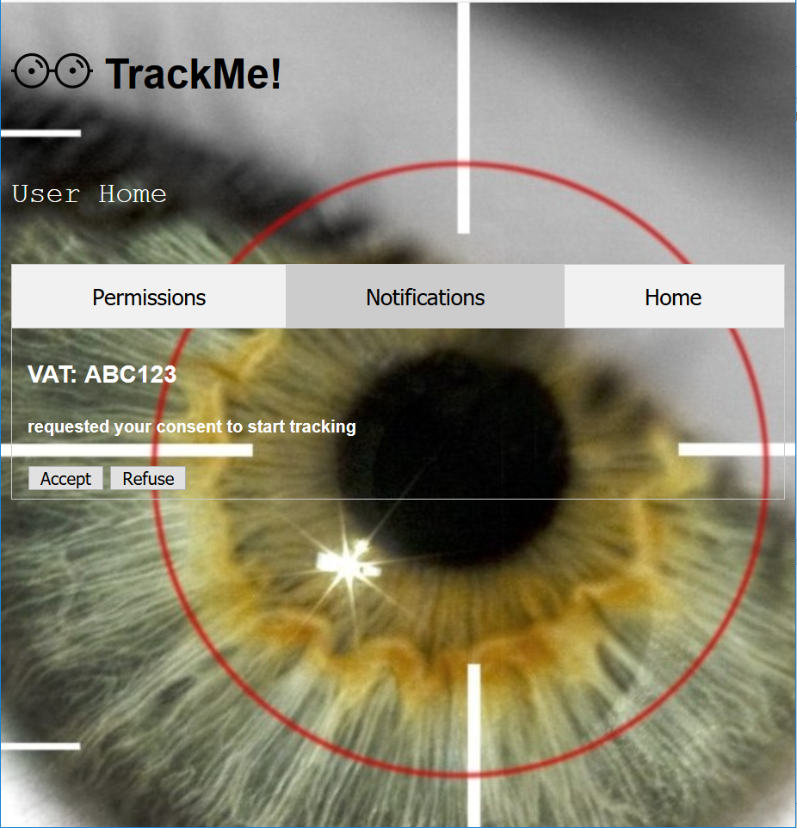

Notifications: real time messages sent from the server

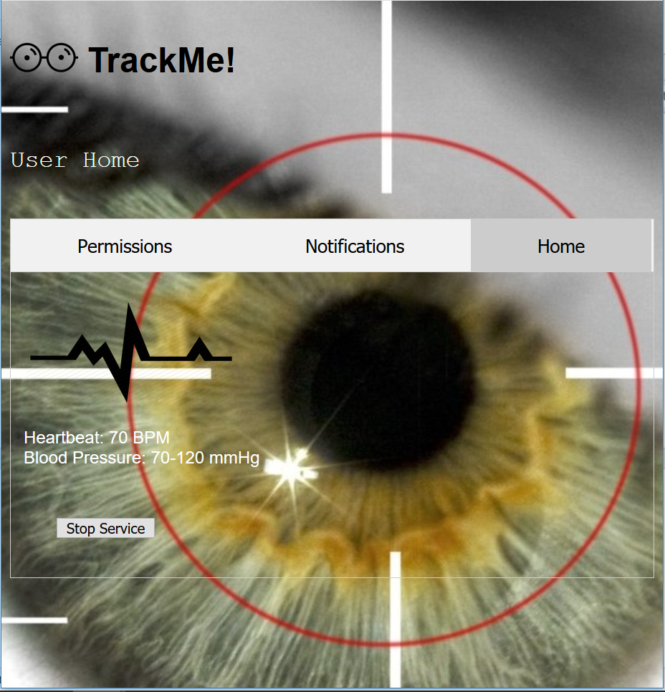

In the home tab, user will see in real-time its vital parameters along with the possibility to stop the service at any time